The Limits of Open-Source Deepfake Detection Tools
Christopher B. Goznalez
John Jay College of Criminal Justice
FCM 798: Faculty-Mentored Research in Digital Forensics & Cybersecurity
Professor Hunter Johnson
11 December 2025

Introduction
In 1950, British mathematician Alan Turing published Computing Machinery and Intelligence in Mind, an academic journal dedicated to philosophy. It is widely agreed that this paper is one of the foundational texts regarding artificial intelligence (AI for short) that tackles the question, “Can machines think?” Turing’s paper established the base for future discussions regarding this topic and how their intelligence may be measured through a game that is now called the Turing Test. It would take an additional five years for the term “artificial intelligence” to be coined in a workshop proposal called “A Proposal for the Dartmouth Summer Research Project on Artificial Intelligence." This workshop took place in the year 1956 and can be considered as the official birthdate of AI technology. It may come as a surprise to most people that the origin of AI was in the mid-20th century, as the common man did not have easy access to this technology until around 2020. In that year, OpenAI (an Artificial Intelligence company) introduced a language model known as GPT-3.
While AI can be interpreted as a breakthrough in science and technology, it is, by no means, perfect and is constantly evolving. What started as a language model has become capable of creation, typically in the form of text, images, and videos. Unfortunately, this power creates the possibility of misusing AI for malicious purposes. An example of AI misuse is deepfakes, which are videos or images of people that have been digitally altered to misrepresent them and spread false information. Fortunately, the Internet offers a variety of deepfake detection tools intended to identify images that have been altered. However, to what extent are open source deepfake detection tools reliable? The purpose of this paper is to explore the nature of deepfake images and assess the overall reliability of the tools found on the Internet when presented with real and deepfake images that will gradually decline in quality.
What is Deepfake Technology?
Oxford Languages defines the term “deepfake” as a video, image, etc., in which a person’s face, body, or voice is digitally altered, typically used maliciously or to spread false information regarding the person. Of course, the production of deepfake media is extremely dependent on AI. In most cases, users provide an image to a deepfake image generator and give the AI a prompt that explains how they want the original image to be altered. Then, the technology uses the given information to produce a new image with the requested alterations. A simple search for deepfake image generators will return hundreds of open-source services that can supposedly perform this job. This is because AI technology is always competing with other AI technologies, especially in terms of maximizing user satisfaction while reducing the time and energy needed for the AI to operate. In fact, according to Making an image with generative AI uses as much energy as charging your phone by Melissa Heikkiläarchive (2023), it is revealed that “Generating 1,000 images with a powerful AI model, such as Stable Diffusion XL, is responsible for roughly as much carbon dioxide as driving the equivalent of 4.1 miles in an average gasoline-powered car” (Heikkiläarchive, 2023, paragraph 6). Using this quote, it can be determined that a single image created by Stable Diffusion XL would produce as much carbon dioxide as driving 0.0041 miles, or approximately 21 feet (6.4 meters). To put that amount of energy in another perspective, it would be the same amount needed to fully charge a smartphone (as the title implies). In comparison, Heikkiläarchive (2023) reveals that using AI to create a text 1,000 times would only take as much energy as 16% of a smartphone charge (Heikkiläarchive, 2023, paragraph 1). This shows that AI image technology (and by extension, deepfake technology) is a massive advancement in technology. Fortunately, AI engineers have discovered ways to significantly reduce the cost (and time) of this technology by using a hybrid approach.
A hybrid approach to image technology (like deepfake technology) combines two or more preexisting techniques to create images/videos that should be higher quality, faster, and more efficient to use. In other words, to understand hybrid approaches, it is required to learn the preexisting techniques this approach references. Establishing a definitive origin for hybrid approaches is difficult, as it is technically based on said preexisting techniques. However, it is believed that the earliest hybrid models emerged around 2018. News articles suggest the existence of a hybrid image-generation tool that uses an autoregressive model and a small diffusion model to create high-quality images quickly than state-of-the-art approaches. According to an article published in the MIT News by Adam Zewe (2025), this tool is known as HART, which is short for hybrid autoregressive transformer. The generation process of quality images consumes fewer computational resources than diffusion models, but is nine times faster (Zewe, 2025, paragraphs 4-5). The significance of this quote is that hybrid models allow for optimal resource and time efficiency by addressing the weaknesses of one given deepfake method using the strengths of another method. Additionally, Zewe explains this technology works by first using an autoregressive model to capture the big picture, followed by a small diffusion model to refine the details in the image (Zewe, 2025, paragraph 3).
It is worth mentioning that autoregressive models are traditionally intended to be used for deepfake detection rather than generation but have managed to be incorporated in deepfake technology. IBM defines an autoregressive model as a powerful technique that provides interpretable and reliable predictions if the data contains correlations across the time steps. (IBM, 2024, paragraph 2).
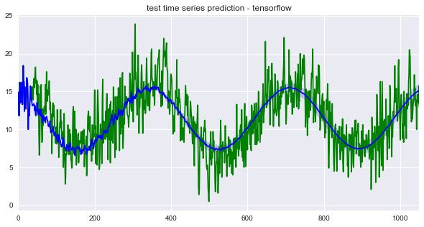 Visual Example of an autoregressive model prediction (blue line) based on given data (green).
In the case of HART, it uses the prediction capabilities of autoregressive models to find inconsistencies in a photo, which is then corrected by a diffusion model. According to What are Diffusion Models? by Muhammad Raza (2025), diffusion models work by simulating a process where the data in a photo is corrupted with “noise”, and then the model learns how to reverse the noise to recover the original data (Raza, 2025, paragraph 6). It is important to note that “noise” in this context does not refer to audio but is rather best described as a visual static that makes the image impossible to interpret with the human eye, but not the AI. A visual that demonstrates the concept of noise in an image is provided on the following page:
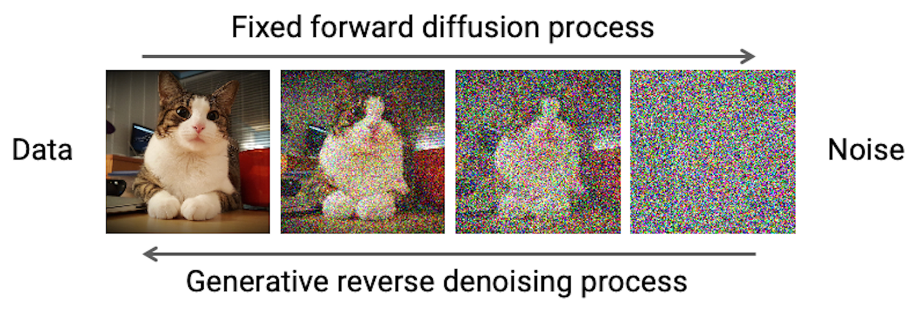 Visual example of a diffusion model reversing the “noise” to recover the original photo.
In the context of a deepfake video, the approach needed to generate a video follows the same principles as the hybrid approaches to deepfake image generation. However, generating a video is far more complex than generating an image, requiring more time, resources, and techniques to create quality videos. An example of a hybrid AI video generator is CauseVid. According to CauseVid Hybrid AI Generates Smooth, High-Quality Videos in Seconds published by Ki Ecke & Tech Momentum (2025), the technology works using a combination of video prediction methods and generative AI tools to (allegedly) create videos in seconds (Ki Ecke, 2025, paragraph 1). The use of “video prediction methods” in this article suggests that CauseVid incorporates autoregressive models-like techniques for videos, while the use of “generative AI tools” is left open for interpretation. Given what was already established about autoregressive models, the generative AI tools in question most likely refer to technologies that assist in polishing the product based on the inconsistencies detected by the autoregressive model. As a reminder, hybrid approaches are not necessarily restricted to one preexisting AI model. As the models’ hybrid approach references are continuously invented/improved with time, the approach should do the same.
Harmful Applications of Deepfakes & Their Legal/Ethical Implications
While deepfake technology can be used in ethical/legitimate applications (i.e., education, accessibility needs, historical reenactment), deepfakes can be created with malicious intent/purposes. Of course, the way all technology is used depends on a user’s morals. For example, realistic audio or video can be used to impersonate executives or relatives to commit financial fraud. As a reminder, although the purpose of this paper is to discuss deepfake technology in the context of images, the term “deepfake” includes generated audio and videos. In addition to verbal impersonation, deepfake technology could influence/alter politics and public opinion, whether through media or audio recordings, which would create confusion for the public. In a more extreme scenario, deepfakes can produce non-consensual sexual content (images/videos) that can damage a person’s reputations and initiate online harassment. Finally, the technology could be used to blackmail targets by generating deepfake images and then using them to threaten people into performing actions they wouldn’t normally take.
Deepfake technology raises several legal and ethical considerations as well due to its potential for harmful misuse. For instance, using someone’s voice, appearance, or creative work without the proper permission could result in civil cases regarding copyright and “property” as defined by the law. Second, using deepfakes for the purposes of fraud and/or identity theft is a crime that can be punishable under cybercrime laws, which continues to grow in significance for society. In cases of harassment and non-consensual content, some laws criminalize the creation/distribution of harmful deepfakes such as the Computer Fraud and Abuse Act (18 U.S.C. § 1030) and the recently made TAKE IT DOWN Act (which is short for Tools to Address Known Exploitation by Immobilizing Technological Deepfakes on Websites and Networks Act).
Ethics, on the other hand, are individual moral principles that are intended to guide personal conduct. However, unlike the law, the choice to follow said principles depends on the person. Making deepfakes of people without their consent (especially in misleading situations) is unethical by society’s standards. While the technology can be fun for creative purposes, content that harms or misleads the victim and/or audience can have unintended consequences depending on the severity. It is strongly encouraged that people avoid the weaponization of deepfake technology to influence politics, create misinformation, or promote violence, as some ethics influence the law and, by extension, consequences.
Research Proposal
Deepfake images have become increasingly common in the modern era, which poses significant issues regarding misinformation, fraud, and trust on the Internet. To mitigate these issues, people have created open source deepfake detection tools that should be capable of distinguishing between real and edited images. Of course, the success of these deepfake detection tools (which, ironically, use AI) ultimately depends on the training, budget, and coding of these platforms. While some deepfake images can be easily identified by the human eye and technology, advanced deepfake images can embed invisible digital watermarks directly into image pixels, which can only be identified by special (and likely expensive) software. Additionally, the engineers behind open source deepfake detection tools may fail to take into consideration whether the quality of an image, both real and deepfake, could generate false positives and/or false negatives. On the Internet, media can include compressed or low-quality images because of frequent sharing, especially on social media platforms/messaging apps. With this in mind, understanding how compression affects deepfake detectors in addition is crucial to evaluating the overall reliability of these tools.
To determine the limits of open-source deepfake detection tools, an experiment was conducted to answer whether open-source deepfake detection tools are reliable, in general, and whether compressing images (both real and deepfake) affects the accuracy of these tools such that it produces false positives and/or false negatives.
Methodology
There are hundreds of services on the Internet that are intended to determine if an image is real or a deepfake. Most of these services are highly limited, in terms of usage, as they only allow users to upload a specific number of images per day or require a form of payment. Understandably, running an AI service is expensive and these deepfake detection tools would (hopefully) perform better than the few open source deepfake detection tools that are completely free to use. This study evaluates the performance of three open-source deepfake detection tools, which are listed below:
- FaceOnLive Deepfake Detector (https://faceonlive.com/deepfake-detector/)
- DFDetect(https://deepfake-detect.com/)
- BrandWell AI Image Detector (https://brandwell.ai/ai-image-detector/)
The reason these deepfake detection tools were chosen is because the services are entirely free to use and do not require payment nor an account as of conducting the experiment. To begin, FaceOnLive is a technology company that claims to offer a variety of services, including an ID Verification SDK Suite, Biometric Authentication, and ID Document Recognition SDK. While these services require payment, the company also provides free tools such as reverse image search, a sales pilot, and the AI Generated Image & Deepfake Detector. The way the deepfake detector works is when the user uploads an image onto their interface, the service will produce a report that explains whether it believes the image is real, manipulated, or indeterminate. This is expressed via a statement and percentage that corresponds to the likelihood the given image is real or manipulated. Predictions of real images would produce a percentage close to 0% while manipulated image would produce a percentage closer to 100%.
Next, DFDetect is a simple deepfake detector that claims to have been built through extensive training and hyperparameter tuning, such as comparing different EfficientNet models, number of convolution layers, weights, data augmentations, dropout rates, and regularizers. To use this tool, the user must upload an image to the interface, and then the detector will provide a prediction result out of 100%. Predictions of real images would produce a percentage close to 100% while manipulated image would produce a percentage closer to 0%. One notable feature that DFDetect offers is that it can detect and analyzing multiple faces in a given image, which is not the case for the other open source deepfake detection tools mentioned. However, if the service cannot determine whether the provided image is real or manipulated, it will not produce a prediction percentage, thus suggesting the detector is uncertain.
Finally, BrandWell is an AI-driven platform that is designed to facilitate brand growth and development. It is an all-in-one platform intended for marketers and creators that help businesses create high-ranking content, understand audiences, and convert visitors into leads from a single dashboard. Some of the features/functions offered by BrandWell include WriteWell, Content Intelligence, and TrafficID, which require payment. Like FaceOnLive, BrandWell offers some free tools as well, such as a general AI Detector, a Plagiarism Detector, and the AI Image Detector. The user can either upload an image directly onto the interface or provide the URL of the image they want evaluated. The tool claims it evaluates image pixels, smoothness, and other AI image patterns to detect AI generation. However, the tool requests for images to be of adequate resolution and quality, which may suggest it struggles with low-quality images. Once an image is provided, a Human vs AI Probability percentage is calculated. The sum of the probability percentage calculated for human and AI is always 100, and whichever percentage is higher would suggest the prediction of the image detector.
A total of two hundred images were collected for this experiment, half of which are real images, and the other half are fake. The images that were used come from a dataset posted on Kaggle (https://www.kaggle.com/datasets/manjilkarki/deepfake-and-real-images), specifically from the “Test” directory. It is stated by the user who uploaded this dataset that the manipulated images are the faces which are created by various means, and that each image is a 256 X 256 jpg image of human face, either real or fake. The “Test” directory contained a total of 5,492 fake images and 5,413 real images, so the two hundred images collected for the experiment were chosen at random. Should the reader be interested in reviewing the exact images that were taken for the experiment, a GitHub link will be provided towards the end of this paper. Once the images were acquired, the accuracy of the three tools were assessed using the original quality of the images. After this, a Python program was created on Jupyter Notebook that compressed the images three times, with increasing levels of quality degradation. For context, compression qualities range from 1-100, though compressing an image with values beyond 30 hardly produce any visual differences. For this reason, the first set of unaltered quality of the images will be referred as having a compression quality of 30. The program was coded to produce the next level of quality degradation as a second set of 200 images with a compression quality of 20, followed by a third set of 200 images with a compression quality of 10, and a fourth set of 200 images with a compression quality of 1.
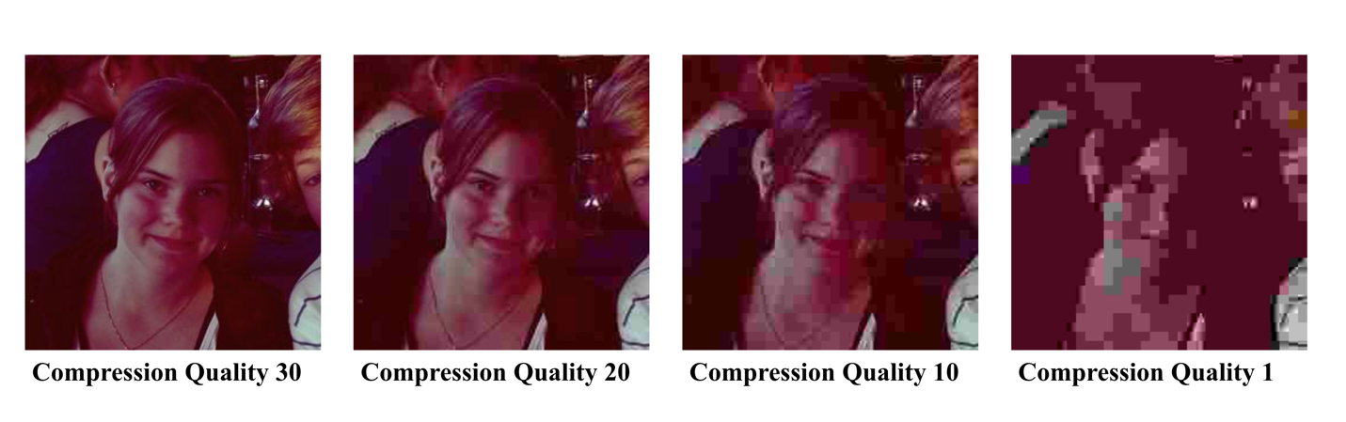
This means that in total, 2,400 evaluations were made across the three open-source deepfake detection tools. The results of each evaluation were recorded in a spreadsheet (CSV format). Once the spreadsheet was complete, a second Python program was created to generate data visualizations and graphs to present the results that were recorded in the spreadsheet. These programs will be accessible in the same GitHub link that will be provided towards the end of this paper. Readers are encouraged to view, test, and improve on the methods used for this experiment as deepfake images is becoming increasingly common in the modern era.
Findings
After testing the limits of the three open-source deepfake detection tools and recording the results on a spreadsheet, it can be concluded that the reliability of these three open-source deepfake detection tools have room for improvement— a lot of improvement. First, the overall prediction accuracy for each deepfake detection tool was calculated and portrayed as a bar graph. The tools were color-coded so that blue represents FaceOnLive, green represents DFDetect, and red represents BrandWell. On one hand, FaceOnLive demonstrated an overall prediction accuracy of 74% across the 800 photos it was given, both compressed and non-compressed. On the other hand, DFDetect and BrandWell have an overall prediction accuracy less than 50% (worse than a coin toss). The bar graph for this finding, which was created through python coding, can be seen below:
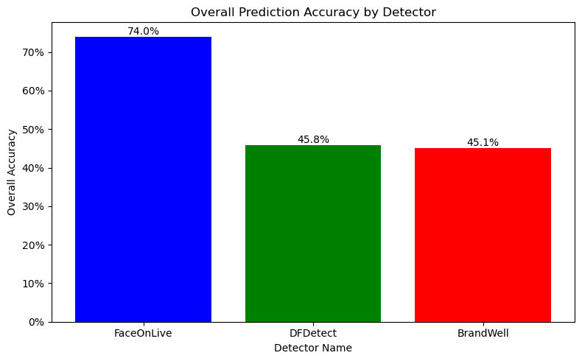
The graph also reveals that BrandWell generally performed the worst out of the three open-source deepfake detection tools, but the difference in prediction accuracy compared the second worst (DFDetect) is only 0.7%. Since each deepfake detection tool evaluated 800 images, this would mean that DFDetect correctly predicted 5-6 more images than BrandWell. The graph can be improved by separating the prediction accuracy to reflect assessments with real and deepfake images. Instead of having one bar per deepfake detection tool, each tool would have two bars, where the first displays real image accuracy and the second illustrates fake image accuracy. This information is presented in the next bar graph on the following page:
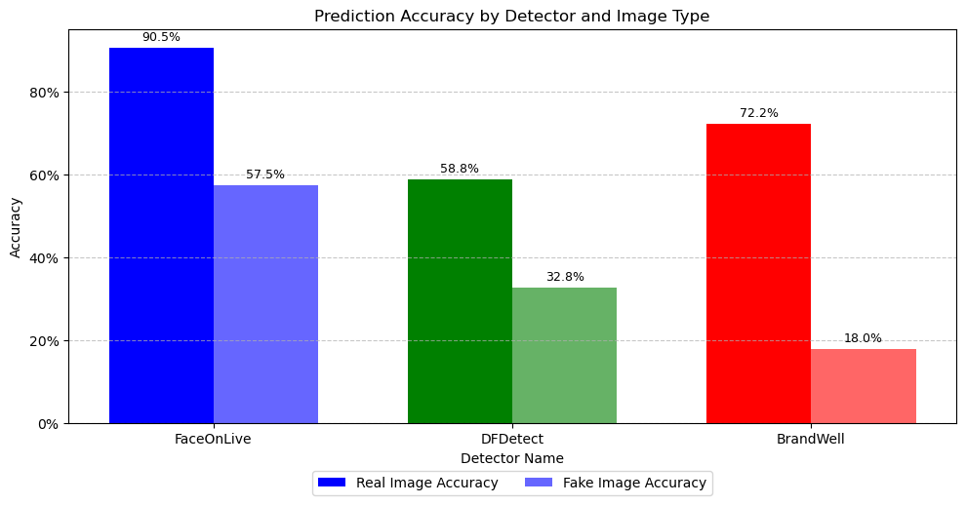
Prior to this graph, FaceOnLive was praised for its overall prediction accuracy of 74%. In this graph, FaceOnLive had a 90.5% accuracy for real images, but a 57.5% accuracy for fake images. Given that these open source deepfake detection tools are intended to detect deepfakes, a 57.5% accuracy is significantly low. Unfortunately, the other deepfake detection tools performed worse. DFDetect had a real image accuracy of 58.8%, which is barely higher than the fake image accuracy of FaceOnLive. Moreover, DFDetect had a fake image accuracy of 32.8%, or less than one-third. Finally, although the real image accuracy of BrandWell was 72.2%, it had the worst fake image accuracy of 18%. In short, all deepfake detection tools performed better in predicting real images than fake images, which undermines their purpose.
As a reminder, each open source deepfake detection tools received 4 sets of 200 images. The first set of images had a compression quality of 30 (original), followed by the second of images with a compression quality of 10, the third of images with a compression quality of 10, and the final of images with a compression quality of 1. A third visual was created to demonstrate the change of prediction accuracy of each deepfake detection tool as the quality of the images decrease from 30 to 1. This visual is a line graph where the x-axis represents the compression quality (starting from 1), and the y-axis reflects the prediction accuracy. Although the axes go beyond their intended range, the visual should be read as if the highest point in the x-axis were 30, and the highest point in the y-axis were 100%:
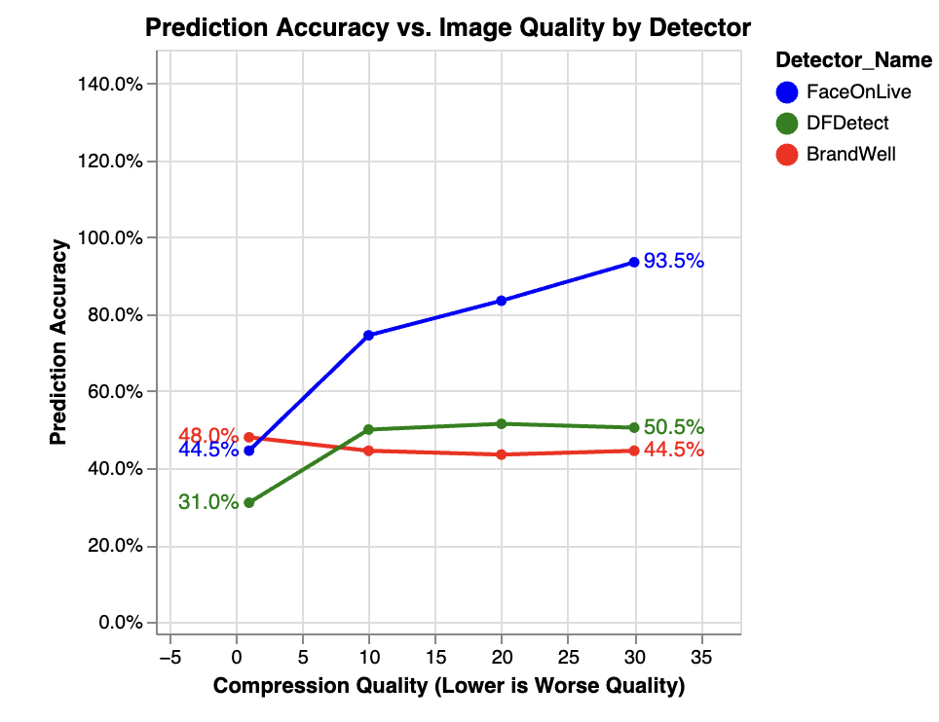
The significance of this graph is that some people could argue the results are wrongfully biased, as only the first set of 200 images would reflect reliable information. The issue with this argument is that images, both real and fake, are not guaranteed to have the highest quality, and so open source deepfake detection tools should properly accommodate for this possibility. From the line graph, it can be determined that, at the highest compression quality, the prediction accuracy of FaceOnLive is 93.5%, while the prediction accuracy for DFDetect is 50.5% and 44.5% for BrandWell. This means that even under the best circumstances, DFDetect and BrandWell perform significantly low and would not be as reliable as FaceOnLive. As the compression quality of the images approach 1, the prediction accuracy for FaceOnLive and DFDetect decrease, which is especially reasonable for compression qualities closer to 1. However, the graph shows that BrandWell “performed better” as the compression quality of the images approached 1. There is no reasonable explanation for this behavior, but this finding will be revisited later in the paper.
The next series of graphs (bar graphs) will enhance the data that was seen in the previous visual by separating the prediction accuracy of each deepfake detection tool in terms of the 4 compression quality levels. Starting with FaceOnLive, the accuracy for images with a compression quality of 30 was 95% for real images, and 92% for fake images. On the other side of the spectrum, the accuracy for images with a compression quality of 1 was 81% for real images, and 8% for fake images. This information and more can be seen below:
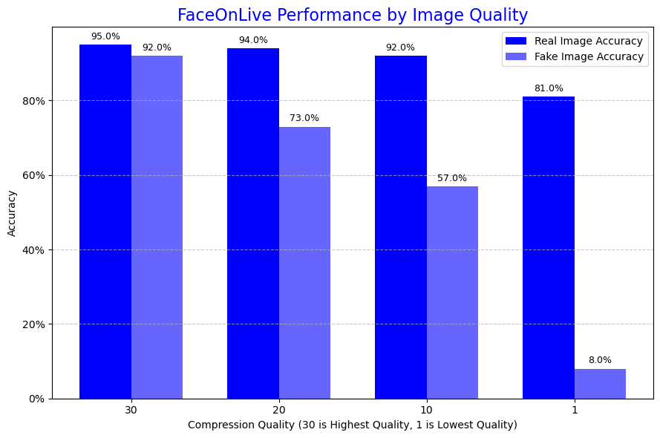
The change in real image accuracy for FaceOnLive is gradual. Even when given images with a compression quality of 1, FaceOnLive’s real image accuracy is surprisingly well. However, the change in fake image accuracy is abrupt, but arguably satisfactory under the circumstances. On the other hand, the pattern seen with FaceOnLive is partially inverted when compared to DFDetect and BrandWell. The performance of DFDetect by image quality is as follows:
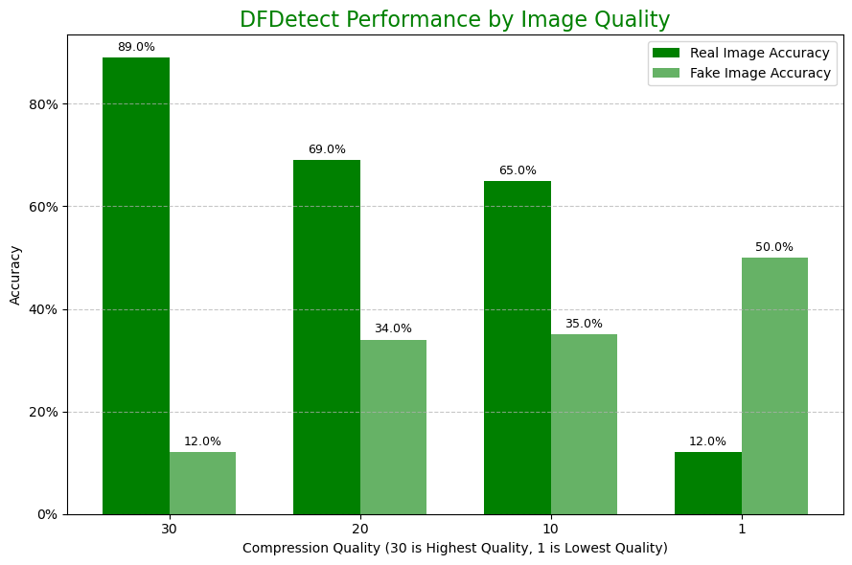
While DFDetect performs exceptionally well with real images at a quality of 30, the decline in real image accuracy goes from 89% to 69%, then 65%, and finally 12%. FaceOnLive completely outperforms DFDetect in real image accuracy. However, the most shocking finding from the graph is that the worst accuracy for fake images occurred with the images in its original quality (30). As this value approached 1, the accuracy for fake images increased from 12% to 34%, then 35%, and finally 50%. A possible explanation for this is that DFDetect assumes an image is fake if there is evidence of subtle image degradation, but even if true, the accuracy is no better than a coin flip for fake images. Finally, the results for BrandWell are perhaps the most surprising of the three open-source deepfake detection tools:
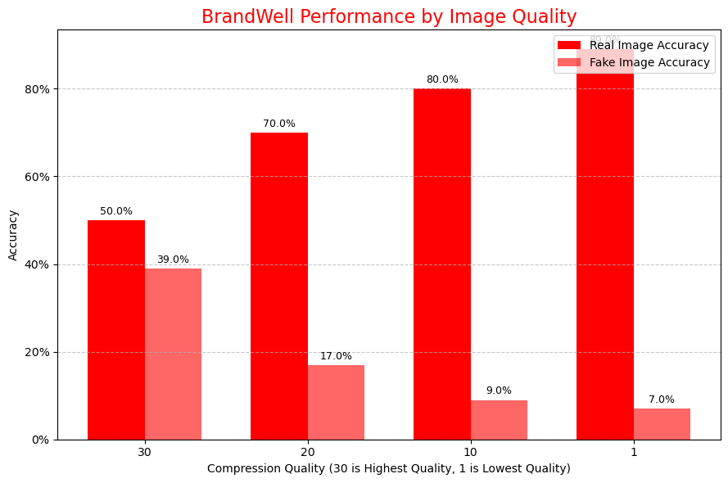
In contrast to both FaceOnLive and DFDetect, the worst accuracy for real images occurred with the images in its original quality at 50%. As the quality approached 1, the accuracy increased from 50% to 70%, then 80%, and finally 89%. There is no reasonable explanation for this behavior as expressed previously, other than perhaps BrandWell’s deepfake detector is trained to predict real for low-quality images by default. This, in turn, could explain why the image accuracy for fake images was highest at a quality of 30 (39%) and lowest at a quality of 1 (7%). Of course, the answer to this mystery can only be answered by those who developed this deepfake detector.
While unrealistic, a perfect deepfake detector would have predicted 400 real and 400 deepfake images without any uncertainty. The data in this experiment reveals that the three open-source deepfake detection tools produced more false positives (predicting an image was real) than false negatives (predicting an image was a deepfake). Fortunately, it is possible to use python to count the exact number of times the detection tools predicted real, deepfake, and uncertain and compare their predictions to the imaginary perfect deepfake detector:
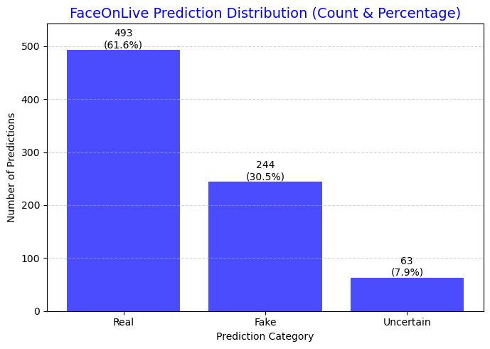
Starting with FaceOnLive, the detector had 493 predictions of “Real”, 244 predictions of “Fake”, and 63 predictions of “Uncertain”. Even though FaceOnLive performed the best out of the three deepfake detection tools, it does have some challenges in detecting fake images. The prediction distribution of DFDetect closely resembles the prediction distribution of FaceOnLive, but this deepfake detection tool had less predictions of “Real” and “Fake”, and more instances of “Uncertain”, as seen on the following page:
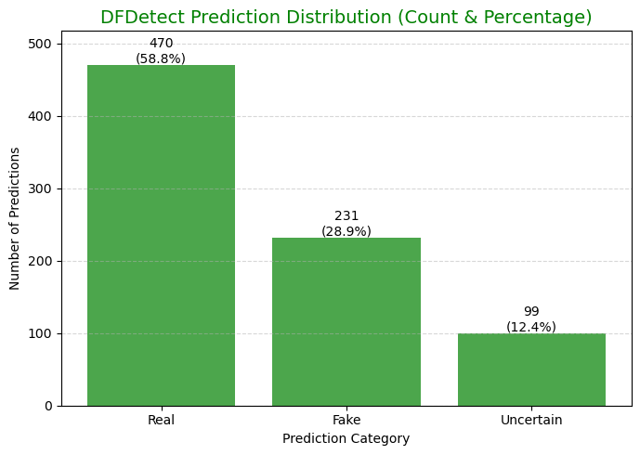
In short, it can be said that DFDetect is inferior to FaceOnLive in all aspects, but the worst performing deepfake detection tool was BrandWell. This detection tool produced roughly 25% more false positives than FaceOnLive (31% compared to DFDetect) but had less instances of uncertainty than the other detection tools. However, readers should be reminded BrandWell’s predictions worked by picking whichever percentage between “Human” and “AI” was higher. In this experiment, uncertainty was recorded whenever the percentage between “Human” and “AI” was exactly 50% for both sides:
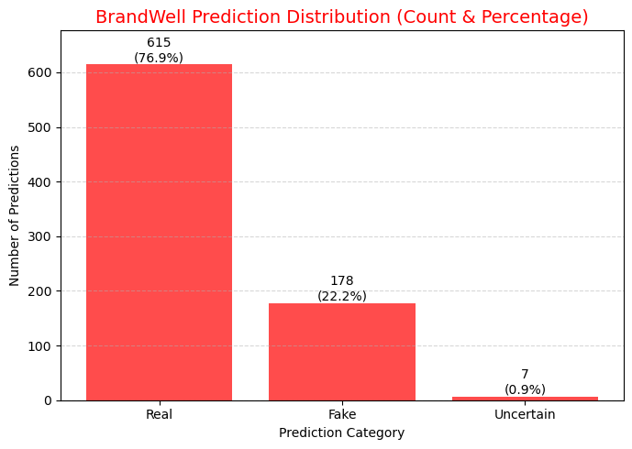
Finally, a classification report for these three open-source deepfake detection tools was created in terms of each detector’s precision, recall, f1-score, and other metrics that are commonly used in data analytics. In the context of data analytics, precision refers to the correct predictions made by the detector out of 1 (100%), where a high precision suggests few false positives. Next, recall refers to the instances the detector produced false negatives out of 1 (100%), and the f1-score is the balance point between the detector’s precision and recall values, acting almost like the average of these two values. To create this report, all instances in which a detector predicted “Uncertain” must be excluded:
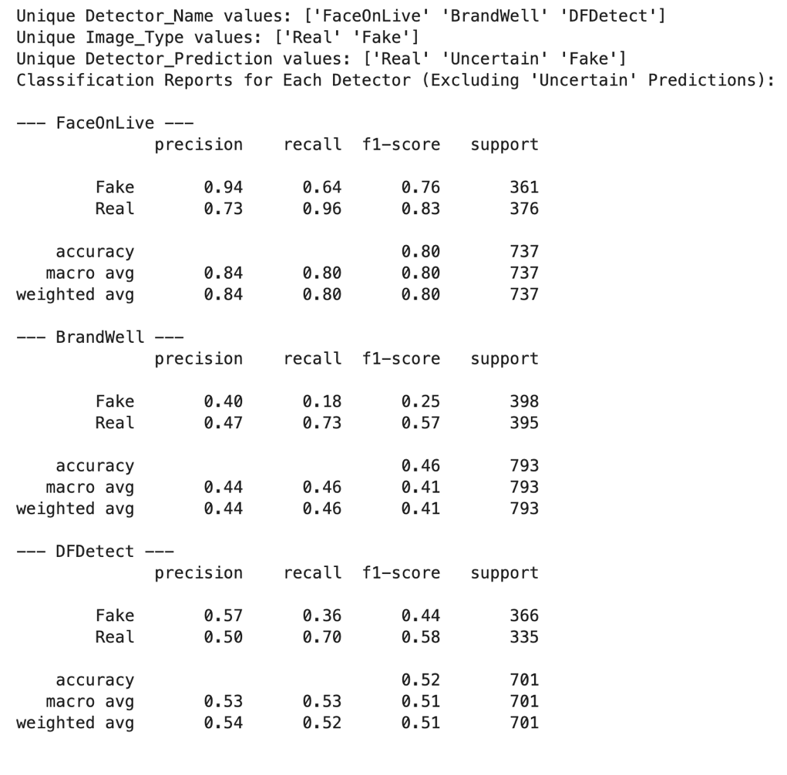
Besides these findings, it was also observed that BrandWell’s deepfake detection tool struggled with images that contained Asian faces and DFDetect cannot see through physical props that obscure faces. In the end, the most reliable open source deepfake detection tool was FaceOnLive, followed by DFDetect and then BrandWell, but that isn’t necessarily to suggest users should be using these tools for their purposes. In fact, it might be better for users to use deepfake detectors coded by graduate students. As a smaller experiment, 10 real and 10 deepfake images were evaluated by a python program created by Jason Charles (my classmate). A visual of his program is provided below:
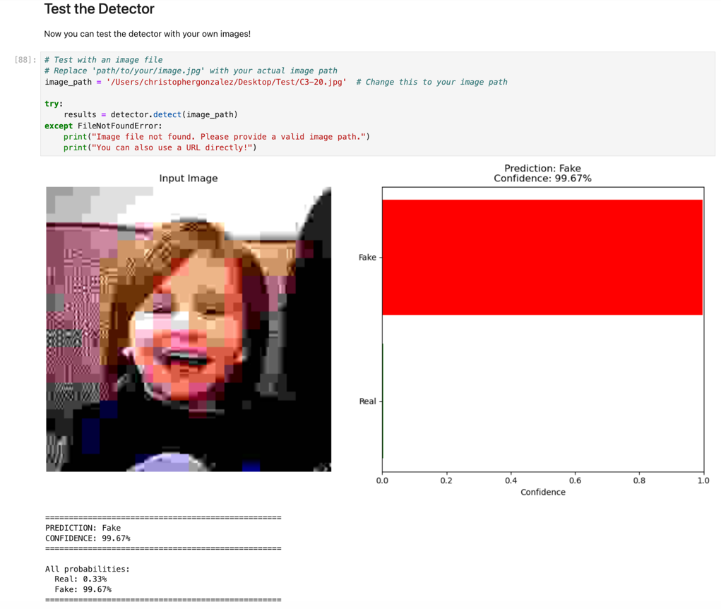
Charles’ program easily outperformed the three open source deepfake detection tools that were tested. His program rarely produced false positives/false negatives as the image quality decreased to 1, and the only prerequisite is to run the program on Jupyter Notebook, which is free to use. It is possible that his program performs at the same quality as deepfake detection tools that require payment, but that is an experiment for those who are inspired by this paper.
Conclusion
This paper set out to explore the nature of images, real and deepfake, and assess the reliability of open source deepfake detection tools when presented with images of gradually declining quality. The experiment evaluated FaceOnLive, DFDetect, and BrandWell and demonstrated that the reliance on these publicly available tools is dicey, as their reliability has significant room for improvement. FaceOnLive showed the highest overall prediction accuracy at 74.0%, while DFDetect (45.8%) and BrandWell (45.1%) performed worse than a coin toss. A critical finding was the consistent deficiency in identifying manipulated content, as all three detectors performed much better at predicting real images than fake images. FaceOnLive achieved a 90.5% accuracy for real images but only 57.5% for fake ones, and BrandWell had an 18.0% fake image accuracy. Furthermore, the study confirmed that image compression severely degrades performance, as shown by FaceOnLive's fake image accuracy dropping from 92% (for images of quality 30) to just 8% (images of quality 1). The data also showed a bias, with the detectors producing more predictions of "Real" (false positives) than "Fake" (false negatives). Although FaceOnLive was the most reliable of the group, the high rate of failure to detect deepfakes across all tested services suggests that free, open source detection tools are insufficient to effectively counter the increasing sophistication and malicious potential of deepfake technology. It is highly recommended for engineer and developers to improve on how open source detection tools are trained and accommodate for image quality and face variations.
GitHub Link
https://github.com/ChrisBGonz/College_Code_Projects/tree/main/Year%205/FCM%20798
References
Heikkilä, M. (2023). Making an image with generative AI uses as much energy as charging your phone. MIT Technology Review. https://www.technologyreview.com/2023/12/01/1084189/making-an-image-with-generative-ai-uses-as-much-energy-as-charging-your-phone/
IBM. (2024, June 12). Autoregressive Model. Ibm.com. https://www.ibm.com/think/topics/autoregressive-model
Ki Ecke & Tech Momentum (2025). CauseVid Hybrid AI Generates Smooth, High-Quality Videos in Seconds. Ki Ecke. https://ki-ecke.com/insights/causevid-hybrid-ai-generates-smooth-high-quality-videos-in-seconds/
Mucci, T. (2024). History of artificial intelligence. Ibm.com. https://www.ibm.com/think/topics/history-of-artificial-intelligence
Raza, M. (2025). What are Diffusion Models? Splunk. https://www.splunk.com/en_us/blog/learn/diffusion-models.html
Zewe, A. (2025, March). AI tool generates high-quality images faster than state-of-the-art approaches. MIT News | Massachusetts Institute of Technology. https://news.mit.edu/2025/ai-tool-generates-high-quality-images-faster-0321

